E-CONTENT

MJMC, SEM-IV, PAPER-XIII (CC- 401)
Topic : Structure of a Typical Newspaper/News Agency
Date : 24-01-2020, TIME : 1.00 P.M.-2.00 P.M.

PREPARED BY : AMIT KUMAR

Structure of a Typical Newspaper/News Agency
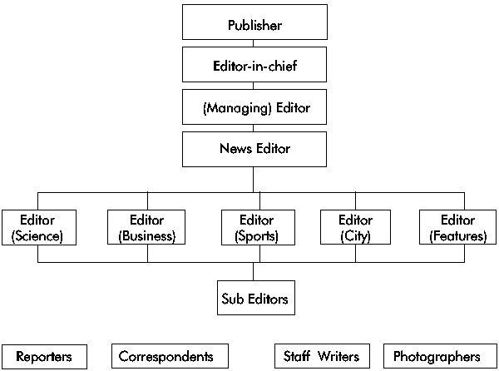
Structure of a Typical Newspaper/News Agency
Your primary targets here are editors, reporters, correspondents, staff writers and photographers. They are the people you are most likely to meet routinely. Target them through periodic, personalized correspondence- letters, information materials addressed to specific reporters/editors by name; invitations to guided tours; routine media briefings -i.e. a press forum where the sole intention is to clarify issues and provide adequate information on critical issues; media breakfasts/dinners social gatherings which are used to convey key information to the media by way of after dinner statements/addresses. The science editor, features editor and the news editor should be targeted through routine guided tours/video screenings of your VNR and media breakfasts/dinners.

